4.1 More Nonlinear Functions and Their Graphs

A polynomial function has the form $f(x)=a_{n}x^{n}+a_{n-1}x^{n-1}+...+a_{0}.$

$f(x)=3x^{4}+2x^{3}-4x^{2}+5x+1$ is a polynomial

$f(x)=2x^{3}-4x^{2}+5x+1$ is a polynomial

$f(x)=1+2x$ is a polynomial. $f(x)=2x + 1$

$f(x)=3$ is a polynomial (a constant is a polynomial)

$f(x)=3x^{-4}+1$ is not polynomial

$f(x) = 5x^{2}+2x+2x^{0.2}$ is not polynomial

$f(x)=\sqrt{x}$ is not a polynomial

$f(x)=\frac{1}{x^{2}+5x-2}$ is not a polynomial

The leading coefficient is the number in front of x with the largest exponent.

For $f(x)=3x^{4}+2x^{3}-4x^{2}+5x+1$, the leading coefficient is 3, because it's the number in front of $x^{4}$

The degree is the largest power or exponent of x.

For $f(x)=3x^{4}+2x^{3}-4x^{2}+5x+1$, the degree is 4, because 4 is the largest power of x.

Ex: $f(x)=-6x^{5}+4x^{2}-2$

What is the leading coefficient? -6
What is the degree? 5

A constant is a number that's alone without x.

For $f(x)=-6x^{5}+4x^{2}-2$, the constant is -2.

Polynomial Functions
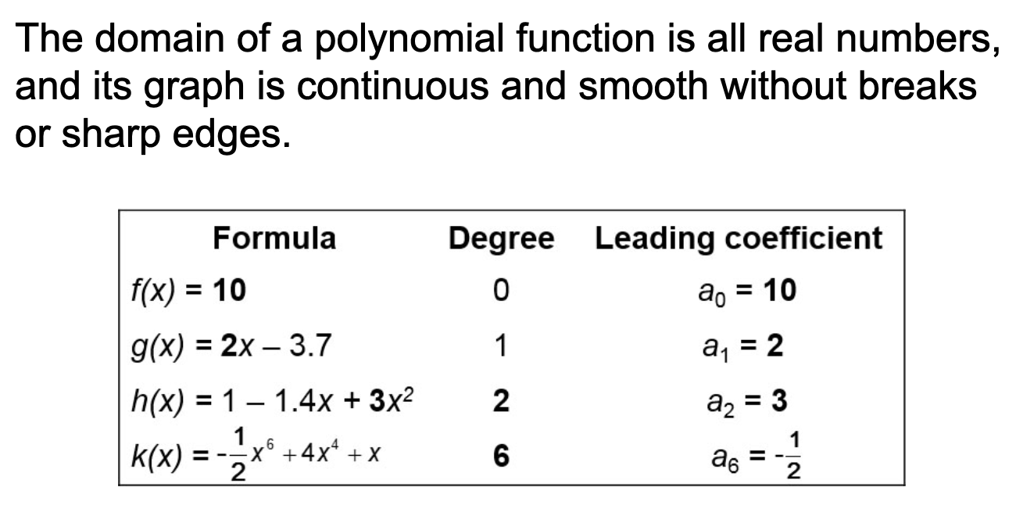

The domain of all polynomials are all real numbers.

Domain: R, (-infinity, infinity)

Absolute and Local Extrema

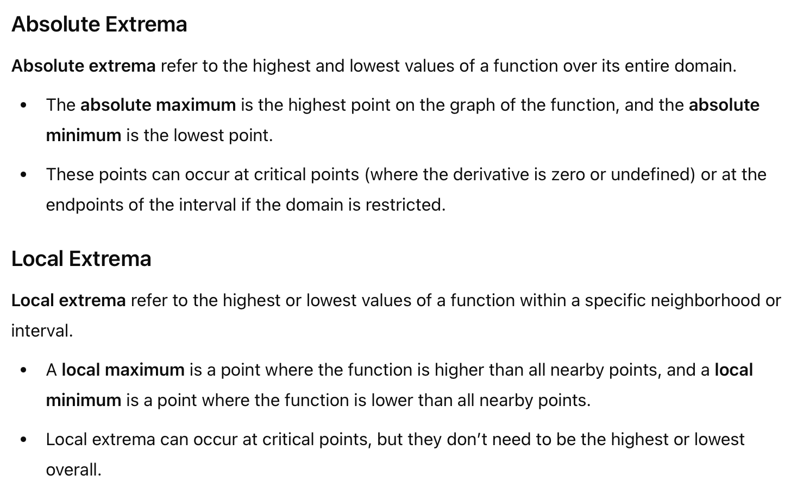
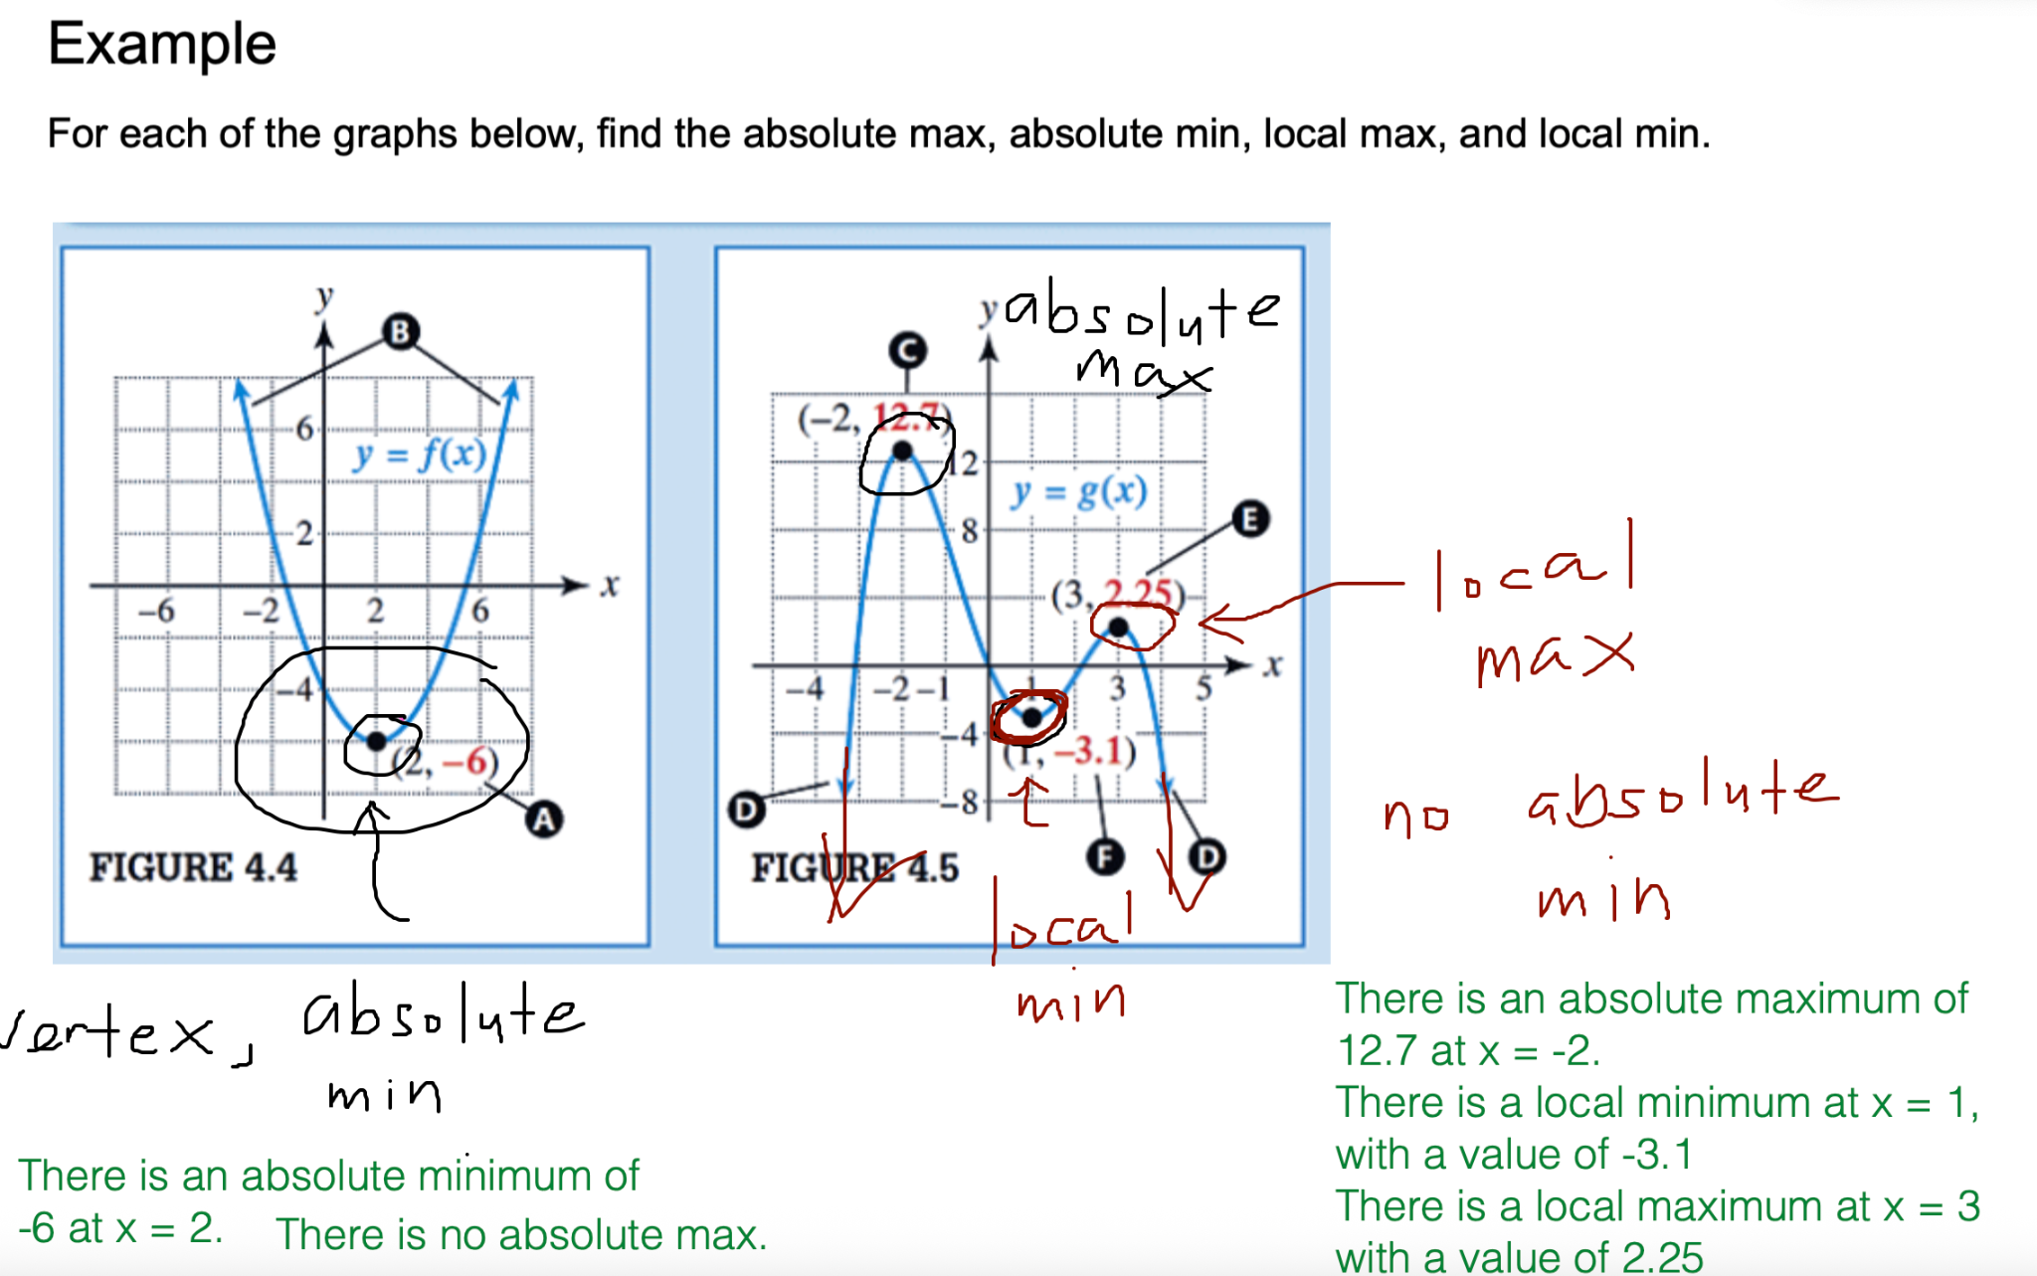

Function Symmetry
A function can be even, odd, or neither. An even function is symmetric with respect to the y-axis. An odd function is symmetric with respect to the origin.

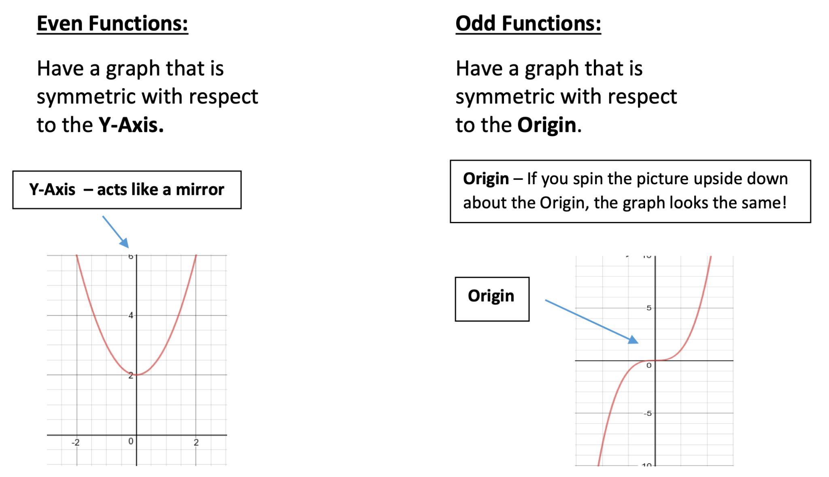

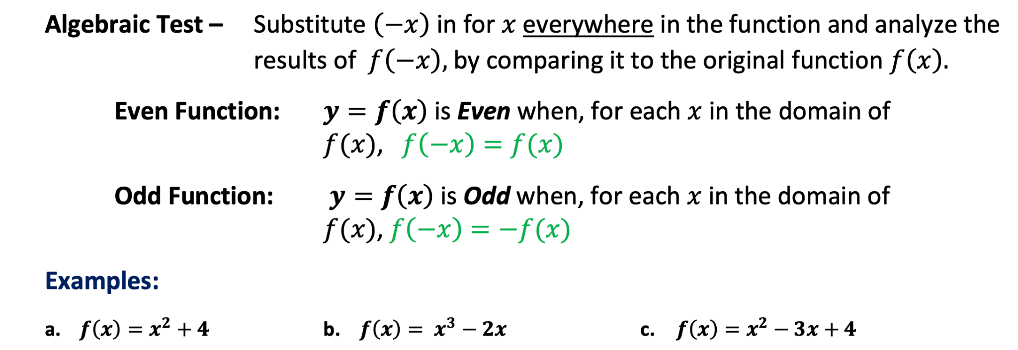

Part (a) Part (b)
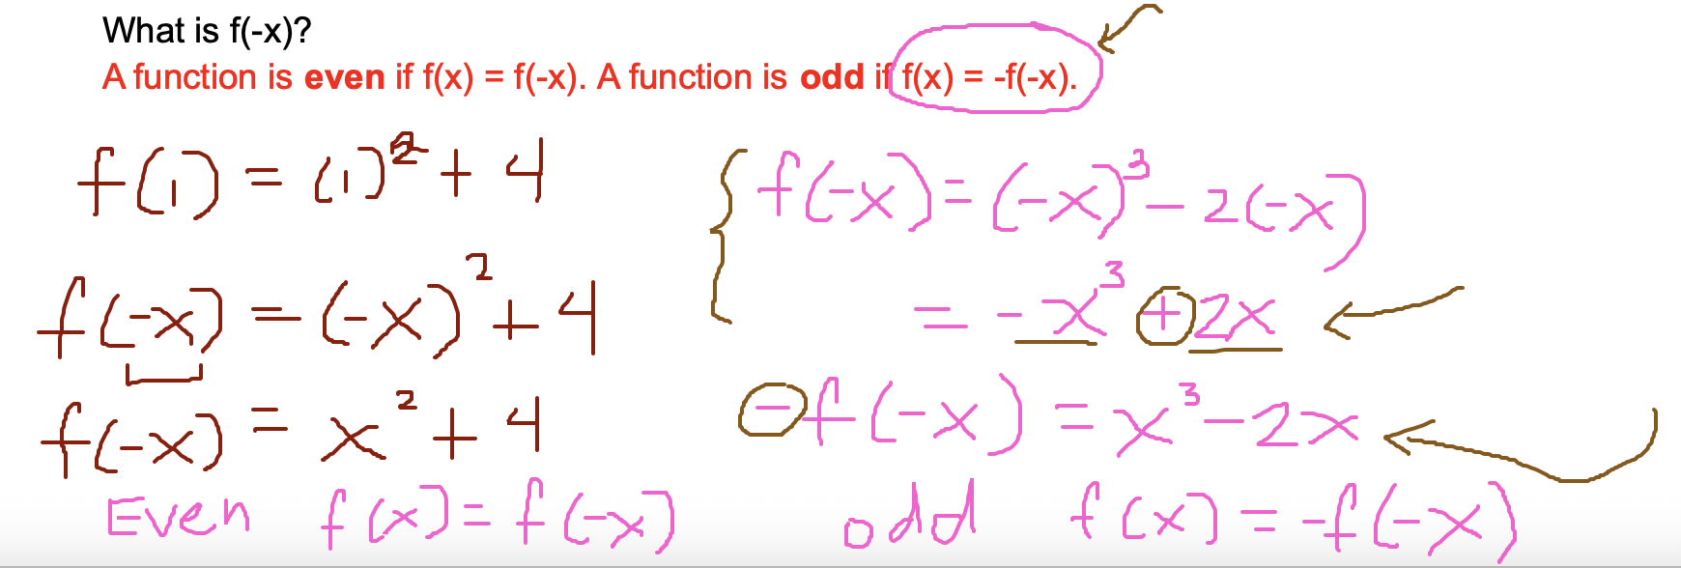

(c)

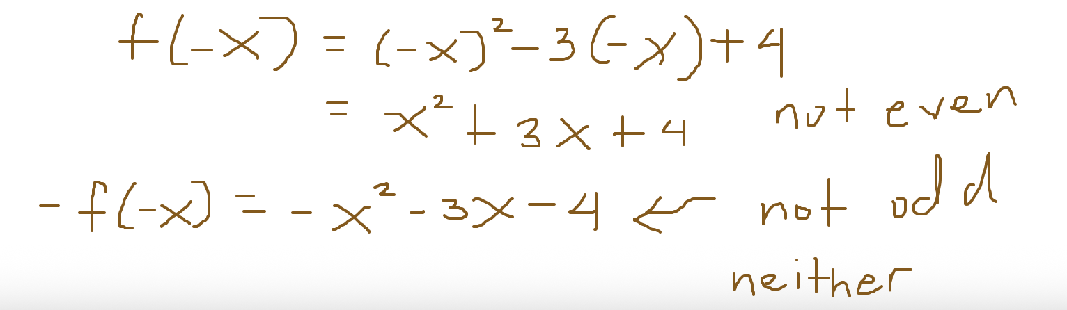

Practice Problems

